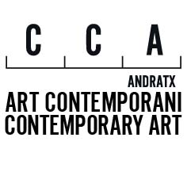

MEDIA TRACK
Anunciando Sculpture Network start’17

MEDIO ONLINE

http://www.bonart.cat/actual/sculpture-network-start17-en-el-cca/

http://www.diariodecalvia.com/cca-andratx-anfitrion-del-sculpture-network-start17/

http://www.artsmallorca.com/en/event-/sculpture-network-start-17

http://www.el-aviso.es/ads/sculpture-network-start17/?lang=es

http://aigab.info

http://www.abc-mallorca.es/event/festival-escultura-cca-andratx/

http://eventerbee.es/event/internationales-fest-fur-zeitgenossische-skulptur,1242042755908882

https://mallorcamagazin.com/veranstaltungen/ausstellungen/skulpturenfestival-andratx.html

RADIO IB3, los entusiastas
Entrevista el viernes, 27 de enero 2017 a las 16.30h

AGENDA
Ultima Hora
Diario de Mallorca

